5.2 Setup MySQL Database Using Ansible

This section will guide you to:

Setup MySQL database using Ansible

This lab has four sub-sections:

* + 1. Establish connectivity between Ansible controller and node machine
    2. Write Ansible YAML script to install Ansible software
    3. Run Ansible YAML script

**Step 5.2.1:** Establish connectivity between Ansible controller and node machine

Validate Ansible connectivity with web servers host group.

execute below commands to install Docker.

ansible –m ping webservers



**Step 5.2.2:** Write Ansible YAML script to install Ansible software

sudo vi mysql.yaml

then, add the following in the file.

* hosts: webservers

tasks:

* name: Install MySQL

action: apt pkg={{ item }} state=installed

with_items:

- libmysqlclient-dev

- python-mysqldb

- mysql-server

- mysql-client

- name: Start the MySQL service

action: service name=mysql state=started

- name: Remove the test database

mysql_db: name=test state=absent

- name: Create deploy user for mysql

mysql_user: user=”deploy” host=”%” password=password priv=*.*:ALL,GRANT

- name: Ensure anonymous users are not in the database

mysql_user: user=’’ host={{ item }} state=absent

with_items:

- 127.0.0.1

- ::1

- localhost

- name: Update mysql root password for all root accounts

mysql_user: name=root host={{ item }} password=password

with_items:

- 127.0.0.1

- ::1

- localhost

Once connectivity is established, write mysql.yaml file and proceed with execution.

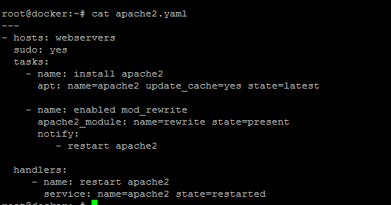

**Step 5.2.3:** Run Ansible YAML script

Run mysql.yaml file using below command:

ansible-playbook mysql.yaml

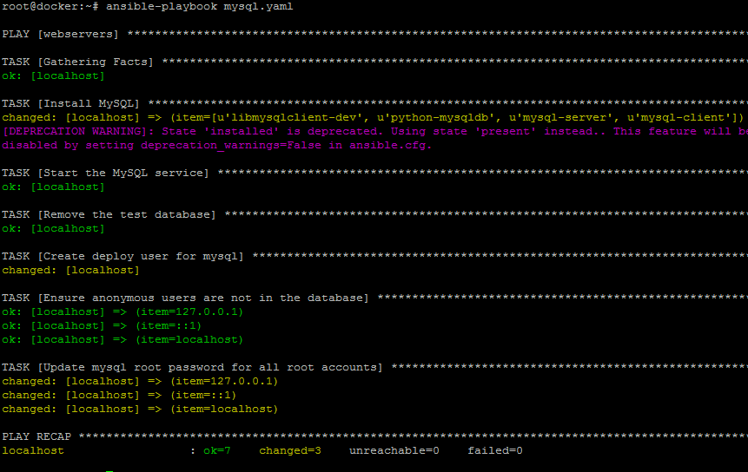

Validate installation using command:

ansible -m shell -a "service mysql status" webservers

